UWB Localization Principle and System Building

A. Localization Principle behind UWB Scheme

1. Basic principle of UWB ranging

(1) TOF (Time-of-Flight ranging method): ranging method belongs to the two-way ranging technology, it mainly uses the signal in two asynchronous transceivers between the Flight Time to measure the distance between nodes. Because in the line-of-sight environment, the TOF ranging method shows a linear relationship with distance, so the result will be more accurate. We denote the time difference between the packets sent and received by the sender as 𝑇TOT, and the time difference between the packets received and sent by the receiver as   
𝑇TAT. Consequently, the one-way flight time of packet in the air, can be calculated as: 𝑇TOF=(𝑇TOT−𝑇TAT)/2

Sender

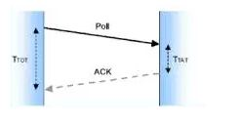

Receiver

But pure TOF algorithm has a relatively strict constraint: the sending and the receiving devices must be running clocks at identical frequencies.

(2). TW-TOF (Two-way Time- of- Flight Method):

a) SS-TWR (Single-sided Two-way Ranging) is a simple measure of the time of a single round-trip message. Device A (the Sender) actively sends data to Device B (the Receiver), and Device B returns data in response to Device A.

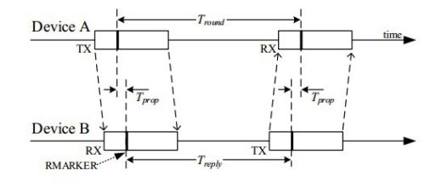

Ranging process: Device A actively sends (TX) data and records the sending time-stamp. After receiving the data, Device B records the receiving time- stamp. After the 𝑇reply delay, Device B sends the data and records the sending time-stamp, while Device A receives the data and records the receiving time-stamp. Based on the two local clocks running at the same nominal frequency 𝑓clk, Therefore, two nominal time differences data can be obtained, respectively 𝑇̂tround and 𝑇̂reply of Devices A and TREPLY of device B. Finally, the nominal flight time 𝑇̂prop of the wireless signal is obtained as follows:

𝑇̂prop≡12(𝑇̂tround−𝑇̂reply).

Assuming the actual frequencies of the clocks are denoted respectively by (1+𝑒A)𝑓clk and (1+𝑒B)𝑓clk, the difference time recorded by the local clocks are

𝑇tround=(1+𝑒A)𝑇̂tround and 𝑇reply=(1+𝑒B)𝑇̂reply. Consequently, the recorded flight time 𝑇prop is given by

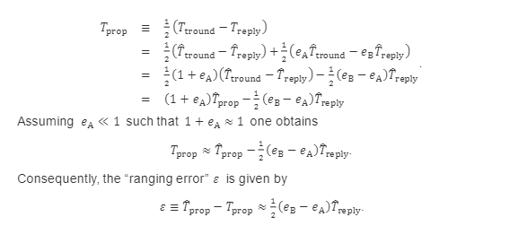

The smaller the 𝑇̂reply, the more accurate the ranging. In addition, 𝑇̂reply covers not only the receiving and sending time of Device B, but also the loading and sending time of data. (In addition to supporting location, UWB can also transmit data: 128 bytes in the Standard Mode, and 1024 bytes in the Extended Mode.) The typical error relationship is as follows: 1 ns is approximately equal to the 750 px ranging error.

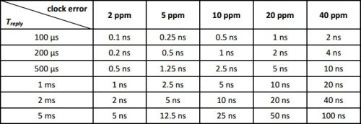

It can be seen that 𝜀 increases with the increase of 𝑇̂reply, 𝑒A and 𝑒B, resulting in inaccurate ranging. Therefore, unilateral two-way ranging (SS-TWR) is not commonly used. It can be used for certain applications, when the demand on accuracy is low but that on a shorter ranging time is high.

b) DS-TWR(Double-sided Two-way Ranging）Double-sided two-way Ranging is an extended ranging technique that records Two round-trip time-stamps to get the flight time. This increases the response time but reduces the ranging error. Double-sided two-way ranging can be divided into two methods according to the number of messages sent:

I. 4 Messages

II. 3 Messages

4 Messages: Device A initiates the first ranging message and Device B responses, generating 2 time-stamps 𝑇round1 and 𝑇reply1; then after some time, Device B initiates the ranging and Device A responds, generating two more time stamps 𝑇round2 and 𝑇reply2.

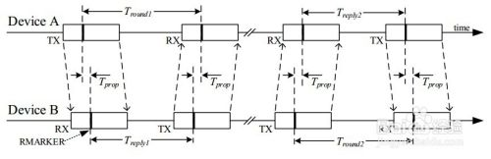

3 Messages: Compared with the 4 message mode, the initiation of the second ranging is avoided. When the Device A receives the data, it will immediately return the data, and finally the following four time differences can be obtained: 𝑇round1, 𝑇reply1, 𝑇round2, 𝑇reply2.

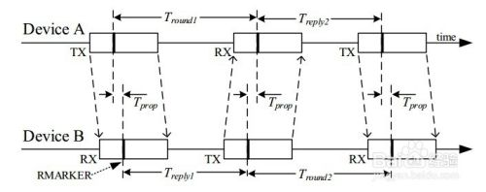

as

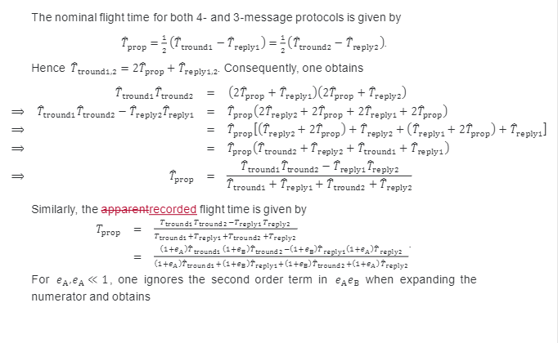

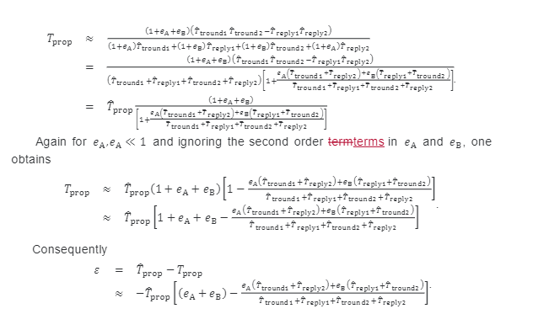

The above ranging mechanisms are asymmetric ranging methods, because they do not have to be the same for response time. Even with a 20 ppm crystal, the clock error is in the picosecond level. The error formula is as follows:

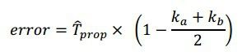

Device A runs at the required frequency 𝑘a𝑓clk, and Device B runs at the required frequency 𝑘b𝑓clk. Both 𝑘a and 𝑘b are close to the value 1.

To figure out the value of the error, if Devices A and B are running with poor crystal oscillation (20 ppm error), for example, Device A is 20-ppm slower, Device B is 20 ppm faster, or put over, this will result in a total error of 40 ppm, so 𝑘a and 𝑘b may be 0.99998 or 1.00002.

Even if the UWB operates over a large range, say 100 m, the air flight time of the wireless signal is about 333ns, because the error is: 20 x 10E-6 x 333 x 10E-9 = 6.7 x 10E-12 = 6.7ps, which is only 2.2 mm after the range is converted.

Note that the response times do not have to be equal, and that the 𝑇reply1 does not have to be equal to the 𝑇reply2, which provides a lot of convenience for MCU system processing.

The main source of error must be whether the timestamp of the received data is correct. Not the PPM of the crystal.

DS-TWR (symmetrical response time): A special example is that the response time of bilateral and two-way ranging method is symmetrical, that is, 𝑇reply1 and 𝑇reply2 are equal. The calculation method of flight time is as follows:

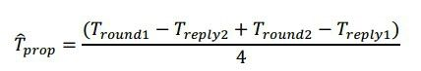

This method just takes a few time-stamps to add and subtract, and then divides by 4 to get the flight time, but it may take more time. The other difficulty with this method is how to ensure that 𝑇reply1 and 𝑇reply2 are equal.

2.UWB positioning principle

The more mature positioning algorithms are: TOA (time of arrival), TDOA (time difference of arrival), AOA (Angle of arrival or called DOA estimation) positioning technology and the mixture of these three technologies.

TOA locates the signal by measuring the travel time of the signal between the mobile terminal and three or more stationary base stations. It uses circumferential positioning.

If the linear distance ruler Ri from the mobile terminal to the base station I is known, then according to the geometric principle, the position of the mobile terminal must be on the circumference with the position of the base station I as the center of the circle and Ri as the radius. That is, if the position of the mobile terminal (X0, Y0) and the position of the base station (Xi, Yi), they satisfy the following relation:



The following figure vividly illustrates the principle of TOA algorithm:

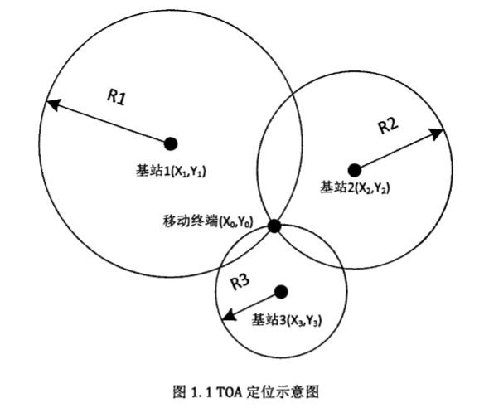

TOA positioning is sensitive to the errors generated in the propagation, which are caused by the interference such as reflection, multipath propagation, non-line-of-sight propagation and noise in the propagation, which may cause the circles to be unable to intersect or the intersection is not a point but a region. At the same time, TOA positioning requires accurate synchronization between the mobile terminal and the base station in time, and the synchronization error of 1ns will bring about 0.3 meters of uncertainty to positioning. Nanosecond synchronization accuracy is not available in many communication systems. Therefore, pure TOA positioning is rarely used in practice.

For this reason, TDOA has improved TOA technology.

TDOA positioning does not need to synchronize between base stations and mobile terminals, but only between base stations. Because base stations are fixed, it is much easier to synchronize between base stations than between base stations and mobile terminals. This makes TDOA positioning much easier to implement than TOA positioning, so TDOA positioning is widely used.

It can locate by measuring the transmission delay difference between two different base stations and mobile terminals. Assuming that the distance difference between the position of the mobile terminal and base stations 1 and 2 is R21=R2-R1, then the position of the mobile terminal must be on the hyperbola with the two base stations as the focus and the distance difference between the two focal points is constant R21. That is, if the position of the mobile terminal is (X0,Y0), the position of base station 1 is (X1,Y1), and the position of base station 2 is (X2,Y2), then they satisfy the relation:



Then another set of hyperbolas can be obtained through the TDOA of another set of mobile terminals and base station 1 base station 3 or base station 2 base station 3. The two sets of hyperbolas will produce at most two intersection points, and then the location of the mobile terminals can be determined according to prior knowledge (such as radius range, etc.).

Its basic principle can be well illustrated by the following picture:

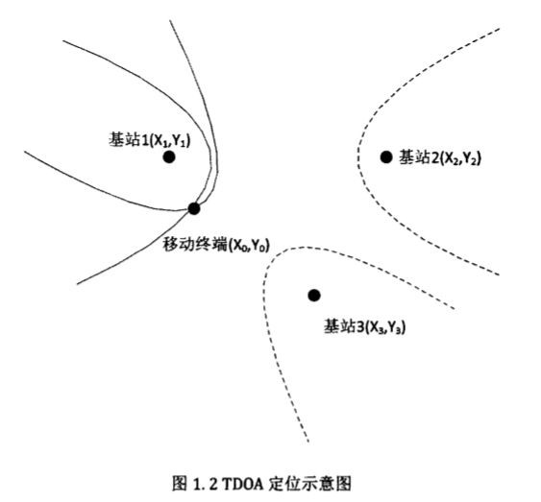

AOA estimation is also called DOA(Direction of Arrival) estimation or DF(Direction Finding).

The advantage of AOA is that it requires fewer base stations, and only two base stations can be used for positioning. Before the LTE system, AOA positioning was not paid much attention because the former base station did not have antenna array and the base station was replaced only for positioning, which not only required huge investment but also destroyed the structure and working mode of the original system, making the communication system unable to work normally. With the application of OFDM and multi-antenna array technology in LTE system, AOA localization based on LTE has become a research hotspot. The disadvantage of AOA is that when the distance between the mobile terminal and the base station is relatively long, even if there is a small error of positioning Angle, it will cause a large deviation of positioning distance. Therefore, AOA positioning is more common in medium and short distance positioning.

The following diagram illustrates the basic principles of AOA well:

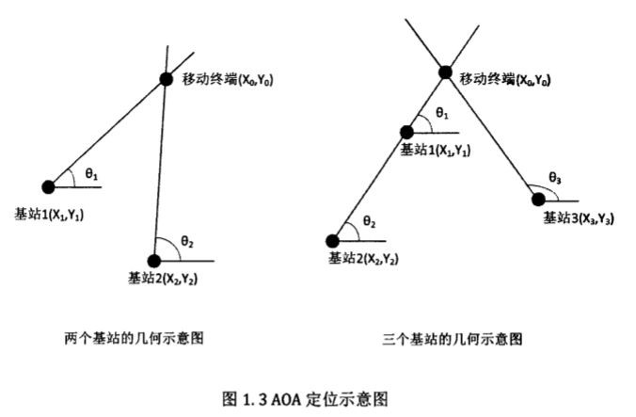

Hybrid positioning technology refers to the mixed use of two or three of the above positioning technologies, such as TOA-TDOA, TOA-AOA, TDOA-AOA, etc., to detect and extract relevant positioning parameters for positioning calculation. Hybrid positioning technology can use a variety of positioning parameters to achieve positioning, comprehensive characteristics of different positioning technology, in the characteristics of each positioning technology to learn from each other, so that the final positioning performance is optimized.

For TOA-AOA based technology, also known as rounded corner positioning, using this method can be achieved by using a single base station for positioning. Firstly, the distance R between the mobile terminal and the base station can be calculated by using the value of TOA, so that the location of the terminal can be determined on the circumference of the circle with the base station as the center of the circle and the radius R. Then use the antenna array to measure the AOA from the mobile terminal to the base station, and make a ray. Then the intersection point between the ray and the circle is the location of the mobile terminal. If the position of the mobile terminal is (X0, Y0) and the position of the base station is (X, Y), the arrival Angle of the signal emitted by the mobile terminal measured in the base station is θ, and the distance between the base station and the mobile terminal is R, then they satisfy the following equation:

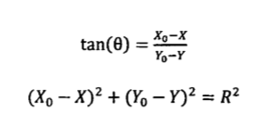

We can vividly understand the positioning process through the following figure:

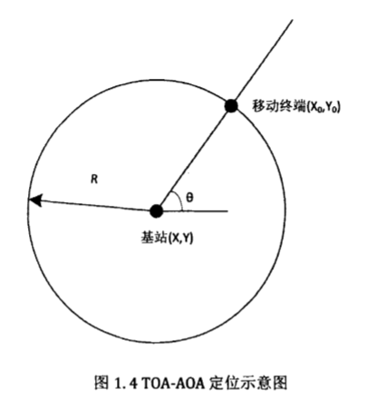

For TDOA-AOA positioning, its positioning principle can be understood through the image below:

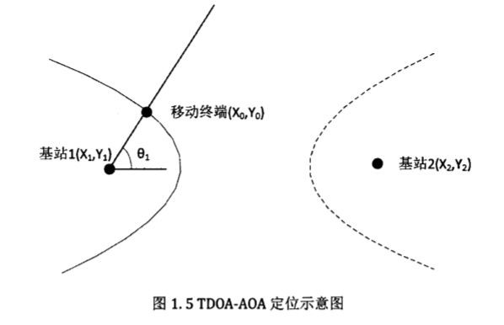

B. UWB Localization System Design

1.Basic method: Multi-base station scheme based on time synchronization

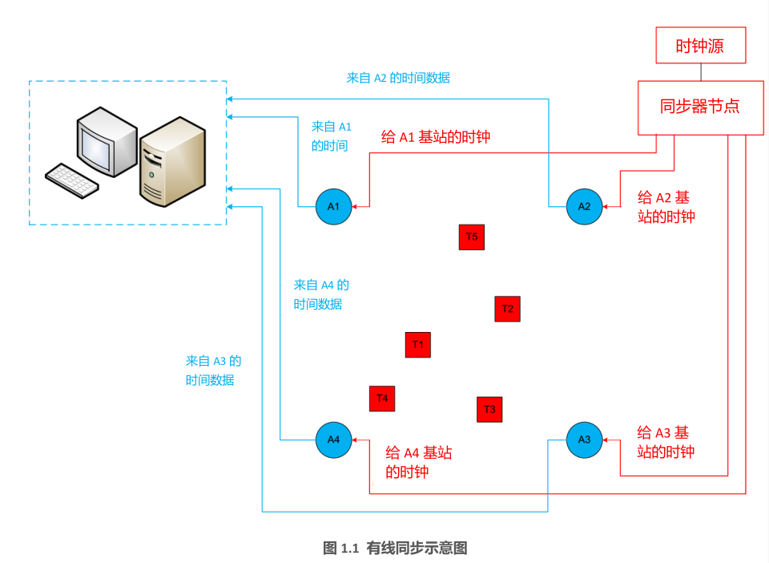

Use the TDOA method. Take T1 as an example to explain the scheme. T1 sends a "broadcast" frame every once in a while. Because A1, A2, A3, and A4 are different from T1, the receiving time is slightly different, and the timestamp is recorded. Since the time of A1, A2, A3 and A4 is synchronized, there is comparability, sent to the local computer for position calculation.

The advantages of this scheme are as follows: at the technical level, the label only sends data to the base station, and the base station does not need to reply data to the label, reducing the data conflict of the whole network; Because synchronizers and base stations are wired, the numbers are highly scalable. With the increase of base stations, positioning speed will not be reduced.

Disadvantages of this scheme: If using the wired synchronization, we need to pull optical fiber. The site layout is cumbersome. Synchronization increases the cost of system (each synchronizer with 4 base stations).

2.Prototype system design

(1) Test the distance measuring system of UWB hardware. Using one base station and one tag.

(2) Start from simple situation. Using the UWB hardware, I designed a simple positioning system, using four base stations and two tags.

In my first time of base station setting, because of the small site conditions, I built the system in a space about 1 by 1 by 1 meter. The system successfully operated. The errors of x axis and y axis are around 0.1 to 0.2 m. and the errors in z axis are even higher.

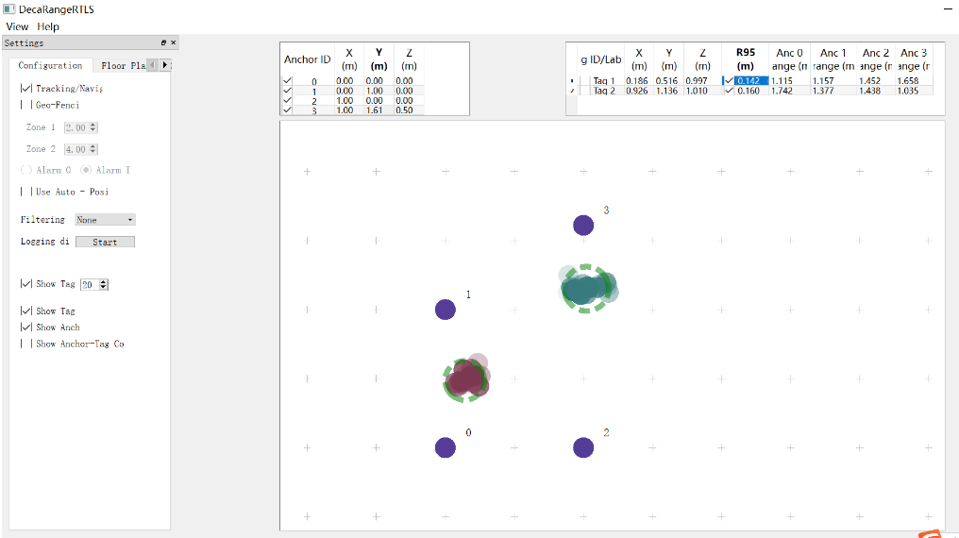

It is not a satisfying result. My guess on the errors is, the space is too small for the system to operate. Next time I will try to build the system in a bigger place, about 10 by 10 by 3 meters. I’m still finding a suitable place which has enough space for the project.